DC Motor:

A **DC motor** is any of a class of rotary electrical machines that converts direct current electrical power into mechanical power. The most common types rely on the forces produced by magnetic fields. Nearly all types of DC motors have some internal mechanism, either electromechanical or electronic, to periodically change the direction of current flow in part of the motor.

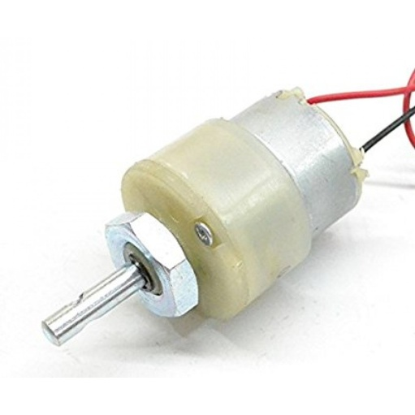

DC motors were the first type widely used, since they could be powered from existing direct-current lighting power distribution systems. A DC motor's speed can be controlled over a wide range, using either a variable supply voltage or by changing the strength of current in its field windings. Small DC motors are used in tools, toys, and appliances. The [universal motor](https://en.wikipedia.org/wiki/Universal_motor) can operate on direct current but is a lightweight motor used for portable power tools and appliances. Larger DC motors are used in propulsion of electric vehicles, elevator and hoists, or in drives for steel rolling mills. The advent of power electronics has made replacement of DC motors with [AC motors](https://en.wikipedia.org/wiki/AC_motors) possible in many applications.

A coil of wire with a current running through it generates an [electromagnetic](https://en.wikipedia.org/wiki/Electromagnetic) field aligned with the center of the coil. The direction and magnitude of the magnetic field produced by the coil can be changed with the direction and magnitude of the current flowing through it.

A simple DC motor has a stationary set of magnets in the [stator](https://en.wikipedia.org/wiki/Stator) and an [armature](https://en.wikipedia.org/wiki/Armature_(electrical_engineering)) with one or more windings of insulated wire wrapped around a soft iron core that concentrates the magnetic field. The windings usually have multiple turns around the core, and in large motors there can be several parallel current paths. The ends of the wire winding are connected to a [commutator](https://en.wikipedia.org/wiki/Commutator_(electric)" \o "Commutator (electric)). The commutator allows each armature coil to be energized in turn and connects the rotating coils with the external power supply through brushes. (Brushless DC motors have electronics that switch the DC current to each coil on and off and have no brushes.)The total amount of current sent to the coil, the coil's size and what it's wrapped around dictate the strength of the electromagnetic field created.

The sequence of turning a particular coil on or off dictates what direction the effective electromagnetic fields are pointed. By turning on and off coils in sequence a rotating magnetic field can be created. These rotating magnetic fields interact with the magnetic fields of the magnets (permanent or [electromagnets](https://en.wikipedia.org/wiki/Electromagnet)) in the stationary part of the motor (stator) to create a force on the armature which causes it to rotate. In some DC motor designs the stator fields use electromagnets to create their magnetic fields which allow greater control over the motor.At high power levels, DC motors are almost always cooled using forced air.

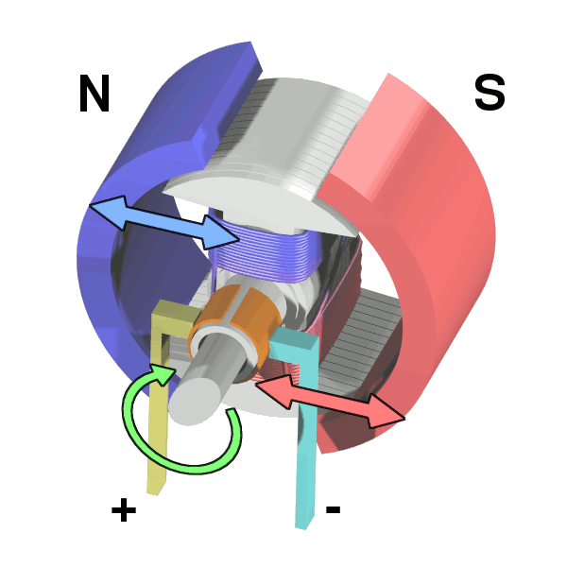

Different number of stator and armature fields as well as how they are connected provide different inherent speed/torque regulation characteristics. The speed of a DC motor can be controlled by changing the voltage applied to the armature. The introduction of variable resistance in the armature circuit or field circuit allowed speed control. Modern DC motors are often controlled by [power electronics](https://en.wikipedia.org/wiki/Power_electronics) systems which adjust the voltage by "chopping" the DC current into on and off cycles which have an effective lower voltage.

Since the series-wound DC motor develops its highest torque at low speed, it is often used in traction applications such as [electric locomotives, and trams](https://en.wikipedia.org/wiki/Railway_electrification_system). The DC motor was the mainstay of electric [traction drives](https://en.wikipedia.org/wiki/Traction_drive) on both electric and [diesel-electric locomotives](https://en.wikipedia.org/wiki/Diesel-electric_locomotive), street-cars/trams and diesel electric drilling rigs for many years. The introduction of DC motors and an [electrical grid](https://en.wikipedia.org/wiki/Electrical_grid) system to run machinery starting in the 1870s started a new [second Industrial Revolution](https://en.wikipedia.org/wiki/Second_Industrial_Revolution). DC motors can operate directly from rechargeable batteries, providing the motive power for the first electric vehicles and today's [hybrid cars](https://en.wikipedia.org/wiki/Hybrid_car) and [electric cars](https://en.wikipedia.org/wiki/Electric_car) as well as driving a host of [cordless](https://en.wikipedia.org/wiki/Cordless) tools. Today DC motors are still found in applications as small as toys and disk drives, or in large sizes to operate steel rolling mills and paper machines. Large DC motors with separately excited fields were generally used with winder drives for [mine hoists](https://en.wikipedia.org/wiki/Mine_hoist), for high torque as well as smooth speed control using thyristor drives. These are now replaced with large AC motors with variable frequency drives.

If external power is applied to a DC motor it acts as a DC generator, a [dynamo](https://en.wikipedia.org/wiki/Dynamo). This feature is used to slow down and recharge batteries on [hybrid car](https://en.wikipedia.org/wiki/Hybrid_car) and electric cars or to return electricity back to the electric grid used on a street car or electric powered train line when they slow down. This process is called [regenerative braking](https://en.wikipedia.org/wiki/Regenerative_braking) on hybrid and electric cars. In diesel electric locomotives they also use their DC motors as generators to slow down but dissipate the energy in resistor stacks. Newer designs are adding large battery packs to recapture some of this energy.